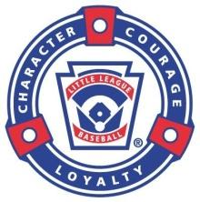
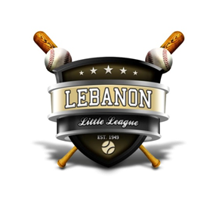
Lebanon Little League
CORPORATE SPONSORSHIP
OPPORTUNITIES
Lebanon Little League is our community’s longest running youth sports organization. Our success at providing quality baseball and softball programs, at a safe and high-end facility, relies heavily on the contributions of local businesses and organizations. In keeping with this trend, Lebanon LL would like to invite you to partner with us to help us expand our program offerings, keep registration costs low, provide certified equipment, and to help improve our facilities. In addition to our normal team sponsorships and banner opportunities, we continue to offer the following levels of corporate sponsorships. Each of these will offer a unique marketing and advertising opportunity for your business or organization.
HOME RUN CLUB $1,800
This level of sponsorship includes naming rights to one field, with a banner on that field’s scoreboard,
banner on a dugout and a banner on fence during the 2021 Spring & Fall baseball/softball seasons.
(quantities limited)

TRIPLE CLUB $1,000
This level of sponsorship includes signage on scoreboard and a banner on the fence during the 2021
Spring & Fall baseball/softball seasons. (quantities limited)

DOUBLE CLUB $600
This level of sponsorship includes signage/name on a dugout and a banner on the fence during the
2021 Spring & Fall baseball/softball seasons. (quantities limited)

SINGLE CLUB $100
This donation would include the sincere gratitude of the Lebanon LL Board, its players and volunteers,
as well as the satisfaction of knowing you have personally made a difference in the lives of our area youth.
Your name will also be part of our sponsor listing on our web site during the 2021 Spring & Fall
baseball/softball seasons.

We understand that monetary donations are not always possible. If that is the case, please consider an in-kind donation. Lebanon LL is always looking to partner with local plumbers, electricians, lawn care/landscaping experts, etc, to help with facility maintenance. We are also open to any ideas or suggestions you may have.

All opportunities listed above would include recognition on Lebanon Little League website, as well as recognition during major events at the facility. Fields, scoreboards and dugouts will be on a 1st come 1st served basis.

Should you choose to support Lebanon LL thru one of these great options, please complete the sponsorship form on the back of this page and forward payment to the address noted.

Sincerely,

Brian Tandy
President, Lebanon Little League
sponsors@lebanonll.org

Lebanon Little League
CORPORATE SPONSORSHIP
OPPORTUNITIES

_____ Yes, I would like to partner with Lebanon Little League as a Corporate Sponsor for the 2021 season.

 | Home Run Club | $1800
 | Triple Club | $1000
 | Double Club | $600
 | Single Club | $100

Lebanon LL is a 501(c)(3) organization, ID 35-6051280

Organization Name______________________________________________________
Contact Person_________________________________________________________
Mailing Address_______________________________________________________________
City, State, Zip_________________________________________________________________
Telephone_______________________ Email_______________________________________

Deadline by March 1, 2021

Check and Letters can be mailed to:
Lebanon Little League, Inc • P.O. Box 324 • Lebanon, IN 46052

For internal League use only

Payment Date: __________ Payment Amount: ____________
Payment Method: _____________ Check #: __________

